A simple demonstration of a recursive template :

{m: self.myTemplate1(1)}

End of demonstration.

{m:template myTemplate1(element : ecore::ENamedElement, depth : Integer)}

{m: element.name.asStyle('Titre' + depth)}

{m:for child | element.eContents()->filter(ecore::ENamedElement)}

{m: child.myTemplate1(depth + 1)}

{m:endfor}

{m:endtemplate}

{m:template myTemplate2(a:Integer)}

{m:if a = 0}

|  |  |  |
| --- | --- | --- |
|  |  |  |
|  | finished |  |
|  |  |  |

finished

{m:else}

|  |  |  |
| --- | --- | --- |
|  |  |  |
|  | {m: a + a} |  |
|  |  |  |

{m: a + a}

{m:(a - 1).myTemplate2()}

{m:endif}

{m:endtemplate}

{m:template myTemplate3(a:String)}

A simple demonstration of a sample image :

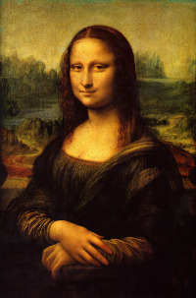

End of demonstration.

{m:endtemplate}

{m:template myTemplate4(a:String)}

A simple demonstration of a sample table :

|  |  |  |  |  |
| --- | --- | --- | --- | --- |
|  | **Bold** | *Italic* | Underline | ~~Strike through~~ |
| **Bold** | **0** | ***1*** | **2** | **~~3~~** |
| *Italic* | ***4*** | *5* | *6* | *~~7~~* |
| Underline | **8** | *9* | 10 | ~~11~~ |
| ~~Strike through~~ | **~~12~~** | *~~13~~* | ~~14~~ | ~~15~~ |

End of demonstration.

{m:endtemplate}